Tugas Kelompok 2
Pemrograman Perangkat Bergerak

Nama Anggota :
1. Raiyana Jan Winata (202310018)
2. Ryan Rohandy Sachio (202310055)
3. Shania Oktaviani Gunawan (202310007)
4. Yudhistira Kusuma (202310067)

Kelas : 4-TI-20-PA1

Perintah/Soal :
Selakan membuat Halaman Profile Page dengan desain bebas, namun antar kelompok tidak boleh memiliki desain layout yg berbeda.
DIkumpulkan perorang namun mengikuti desain layout profile berdasarkan kelompok masing-masing. Dikumpulkan dalam bentuk dokument yg berisi source code + hasil program.
Paling lambat dikumpulkan setelah UTS berlangsung atau pada sebelum perkuliahan dimulai kembali pada sabtu mendatang. Dikumpulkan via LMS untuk file doc dan source code tetap di github.
Tugas ini hanya diperuntukan untuk PA-1, PA-2 tidak perlu mengerjakan tugas pada slide terakhir (karna keterlambatan materi)

File Code
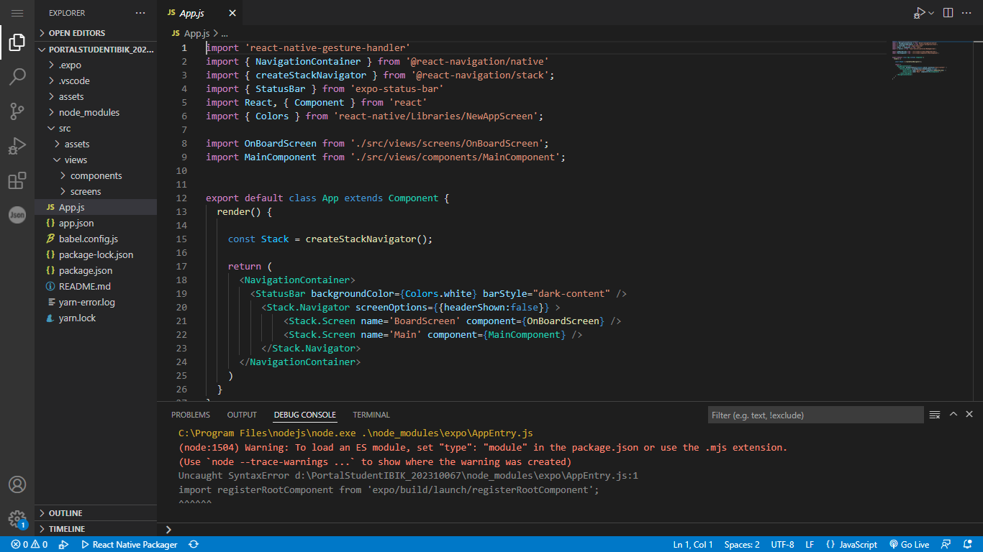



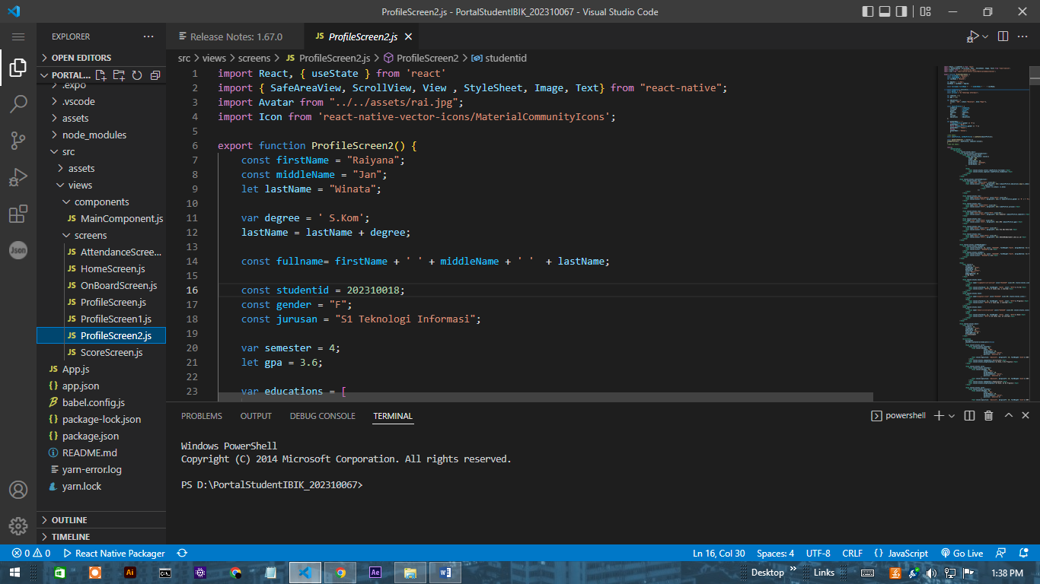
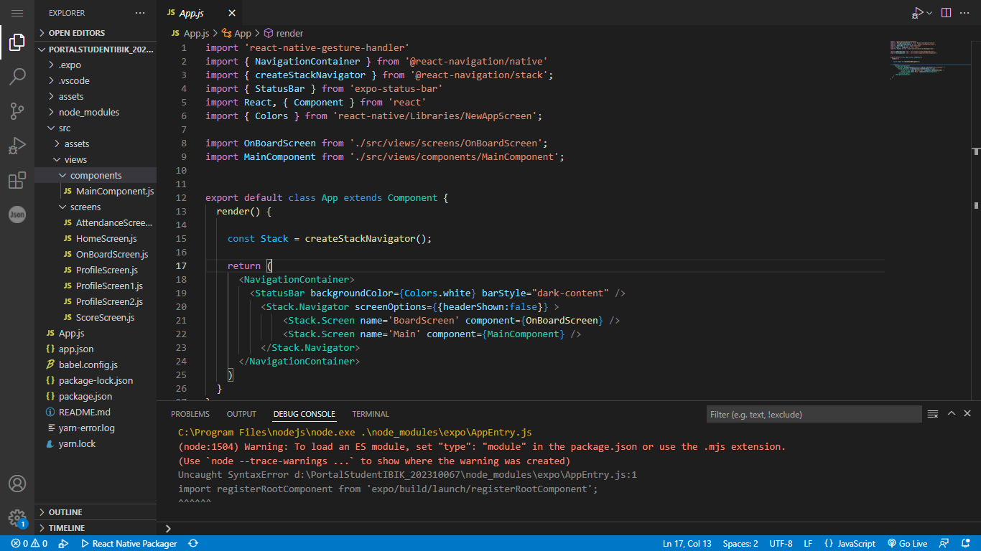
Source Code
- Folder Project

INPUT
ProfilScreen2.js
ProfileScreen2.js
import React, { useState } from 'react'
import { SafeAreaView, ScrollView, View , StyleSheet, Image, Text} from "react-native";
import Avatar from "../../assets/rai.jpg";
import Icon from 'react-native-vector-icons/MaterialCommunityIcons';

export function ProfileScreen2() {
const firstName = "Raiyana";
const middleName = "Jan";
let lastName = "Winata";

var degree = ' S.Kom';
lastName = lastName + degree;

const fullname= firstName + ' ' + middleName + ' ' + lastName;

const studentid = 202310018;
const gender = "F";
const jurusan = "S1 Teknologi Informasi";

var semester = 4;
let gpa = 3.6;

var educations = [
{level: "IBI", school:"Kesatuan", kota:"Bogor"},
];

const objectProfile = {
studentid : studentid,
fullname : fullname,
gender : gender,
semester : semester,
gpa : gpa,
jurusan : jurusan,
educations : educations
};

let genderName = '-';
if(objectProfile.gender == 'M'){
genderName = 'Male';
}else if(objectProfile.gender == 'F'){
genderName = 'Female';
}else{
genderName = 'Unknow';
}

/*USE HOOK*/
const [objProfile, setObjProfile] = useState(objectProfile);

const handlerSemester = (value)=>{
setObjProfile({...objProfile, semester:value});
}
/*END USE HOOK*/

return(
<SafeAreaView>
<ScrollView>
<View style={styles.box1}>
<View style={styles.userInfoSection}>
<View style={styles.head}>
<Image source={Avatar} style={{
height: 100,
width: 100,
borderRadius: 50,
borderColor: "#152529",
borderWidth: 2}}
/>

<View>
<Text style={styles.title}>{objProfile.fullname}</Text>
<Text style={styles.caption}>{objProfile.studentid}</Text>
</View>
</View>
</View>

<View style={styles.userInfoSection}>
<View style={styles.row}>
<Icon name="map" color="#fff" size={20}/>
<Text style={{color:"#fff", marginLeft: 20}}>{objectProfile.educations.map((v,index)=>(
<Text key={index} >
{v.level} {v.school} {v.kota}
</Text>
))}
</Text>
</View>

<View style={styles.row}>
<Icon name="gender-male-female" color="#fff" size={20}/>
<Text style={{color:"#fff", marginLeft: 20}}>{( objectProfile.gender == 'M' ) ? 'Pria':'Wanita' }</Text>
</View>

<View style={styles.row}>
<Icon name="book" color="#fff" size={20}/>
<Text style={{color:"#fff", marginLeft: 20}}>{objProfile.jurusan}</Text>
</View>

<View style={styles.row}>
<Icon name="chart-donut" color="#fff" size={20}/>
<Text style={{color:"#fff", marginLeft: 20}}>Semester {objectProfile.semester}</Text>
</View>

<View style={styles.row}>
<Icon name="star" color="#fff" size={20}/>
<Text style={{color:"#fff", marginLeft: 20}}>GPA {objectProfile.gpa}</Text>
</View>

<View style={styles.row}>
<Icon name="phone" color="#fff" size={20}/>
<Text style={{color:"#fff", marginLeft: 20}}>+62 881-5342-328</Text>
</View>

<View style={styles.row}>
<Icon name="email" color="#fff" size={20}/>
<Text style={{color:"#fff", marginLeft: 20}}>202310018@student.ibik.ac.id</Text>
</View>
</View>

<View style={styles.infoBoxWrapper}>
<View style={styles.infoBox}>
<Text style={{fontSize: 16, color: "#152529", fontWeight:"bold", marginBottom: 5}}>Credit Now</Text>
<Text style={{color: "#152529"}}>84</Text>
</View>
<View style={styles.infoBox}>
<Text style={{fontSize: 16, color: "#152529", fontWeight:"bold", marginBottom: 5}}>Total Credits</Text>
<Text style={{color: "#152529"}}>144</Text>
</View>
</View>

<View>
<Text style={{
fontSize: 22,
fontWeight: "bold",
paddingTop: 20,
textAlign: "center",
color: "#fff",
paddingBottom: 20
}}>My Tasks
</Text>

<View style={styles.task}>
<View>
<Icon name="clipboard-list-outline" color="#152529" size={40} style={styles.icons}/>
</View>
<View>
<Text style={{fontSize: 18, fontWeight: "bold", color: "#fff"}}>To Do</Text>
<Text style={{color: "#fff"}}>5 tasks now. 1 started</Text>
</View>
</View>
<View style={styles.task}>
<View>
<Icon name="progress-clock" color="#152529" size={40} style={styles.icons}/>
</View>
<View>
<Text style={{fontSize: 18, fontWeight: "bold", color: "#fff"}}>Progress</Text>
<Text style={{color: "#fff"}}>1 task now. 1 started</Text>
</View>
</View>
<View style={styles.task}>
<View>
<Icon name="check-circle-outline" color="#152529" size={40} style={styles.icons}/>
</View>
<View>
<Text style={{fontSize: 18, fontWeight: "bold", color: "#fff"}}>Done</Text>
<Text style={{color: "#fff"}}>18 tasks now. 13 started</Text>
</View>
</View>
</View>

<View style={styles.box2}>
<Text style={{
fontSize: 22,
fontWeight: "bold",
paddingTop: 30,
textAlign: "center",
paddingBottom: 20
}}>Achievement
</Text>

<ScrollView
horizontal
showsHorizontalScrollIndicator={false}
>
<View style={styles.card}>
<View style={styles.outerbar}>
<View style={{height: 20,
width: '60%',
borderRadius: 20,
backgroundColor: "white",
position: 'absolute'}}
/>
<Text style={{position: "absolute", marginLeft: 10, fontWeight:'bold'}}>60%</Text>
</View>
<Text style={styles.namamatkul}>Certificate</Text>
<Text style={styles.progressmatkul}>12 Done, 8 On Progress</Text>
</View>

<View style={styles.card}>
<View style={styles.outerbar}>
<View style={{height: 20,
width: '50%',
borderRadius: 20,
backgroundColor: "white",
position: 'absolute'}}
/>
<Text style={{position: "absolute", marginLeft: 10, fontWeight:'bold'}}>50%</Text>
</View>
<Text style={styles.namamatkul}>Organization</Text>
<Text style={styles.progressmatkul}>24 Done, 24 On Progress</Text>
</View>

<View style={styles.card}>
<View style={styles.outerbar}>
<View style={{height: 20,
width: '80%',
borderRadius: 20,
backgroundColor: "white",
position: 'absolute'}}
/>
<Text style={{position: "absolute", marginLeft: 10, fontWeight:'bold'}}>80%</Text>
</View>
<Text style={styles.namamatkul}>Basic Committe</Text>
<Text style={styles.progressmatkul}>80 Done, 20 On Progress</Text>
</View>

<View style={styles.card}>
<View style={styles.outerbar}>
<View style={{height: 20,
width: '60%',
borderRadius: 20,
backgroundColor: "white",
position: 'absolute'}}
/>
<Text style={{position: "absolute", marginLeft: 10, fontWeight:'bold'}}>60%</Text>
</View>
<Text style={styles.namamatkul}>Competition</Text>
<Text style={styles.progressmatkul}>12 Done, 8 On Progress</Text>
</View>

<View style={styles.card}>
<View style={styles.outerbar}>
<View style={{height: 20,
width: '50%',
borderRadius: 20,
backgroundColor: "white",
position: 'absolute'}}
/>
<Text style={{position: "absolute", marginLeft: 10, fontWeight:'bold'}}>50%</Text>
</View>
<Text style={styles.namamatkul}>Apprenticeship</Text>
<Text style={styles.progressmatkul}>24 Done, 24 On Progress</Text>
</View>

<View style={styles.card}>
<View style={styles.outerbar}>
<View style={{height: 20,
width: '80%',
borderRadius: 20,
backgroundColor: "white",
position: 'absolute'}}
/>
<Text style={{position: "absolute", marginLeft: 10, fontWeight:'bold'}}>80%</Text>
</View>
<Text style={styles.namamatkul}>CSP</Text>
<Text style={styles.progressmatkul}>80 Done, 20 On Progress</Text>
</View>
</ScrollView>

</View>
</View>
</ScrollView>
</SafeAreaView>
)
};

export default ProfileScreen2;

const styles = StyleSheet.create({
box1: {
flex: 1,
backgroundColor : "#152529",
borderTopRightRadius: 80,
borderTopLeftRadius: 80,
paddingTop: 10
},
box2: {
flex: 1,
backgroundColor : "#fff",
borderTopLeftRadius: 80,
marginTop: 20,
paddingBottom: 20
},
userInfoSection: {
paddingHorizontal: 30,
paddingBottom: 25,
paddingTop: 10,
},
head: {
alignItems:"center",
marginTop: 15,
justifyContent:'flex-start'
},
title: {
fontSize: 22,
color: "#fff",
fontWeight: 'bold',
marginTop:20,
marginBottom: 5,
},
caption: {
color: "#fff",
textAlign: "center",
fontSize: 16,
fontWeight: '500',
},
row: {
flexDirection: 'row',
marginBottom: 10,
},
infoBoxWrapper: {
flexDirection: 'row',
height: 80,
marginBottom: 20,
marginLeft: 20,
marginRight: 20
},
infoBox: {
width: '50%',
alignItems: 'center',
justifyContent: 'center',
borderColor: '#152529',
borderWidth: 6,
backgroundColor:'white',
borderBottomLeftRadius: 20,
borderTopRightRadius: 20,
},
task: {
flexDirection: 'row',
marginBottom: 15,
},
icons: {
backgroundColor:"white",
borderRadius: 25,
padding: 5,
marginRight: 20,
marginLeft: 20
},
card : {
width: '40%',
backgroundColor: '#152529',
marginLeft: 10,
height:150,
width:200,
elevation:2,
borderTopLeftRadius: 25,
borderBottomRightRadius: 25,
paddingHorizontal: 20,
},
outerbar: {
height: 20,
backgroundColor: "grey",
borderRadius: 10,
overflow: 'hidden',
marginTop: 40,
},
namamatkul: {
paddingTop: 20,
color: "white",
fontWeight: 'bold',
fontSize: 18
},
progressmatkul : {
paddingTop: 10,
color: "white",
fontSize: 12,
opacity: 0.5,
}
});

OUTPUT/RESULT
